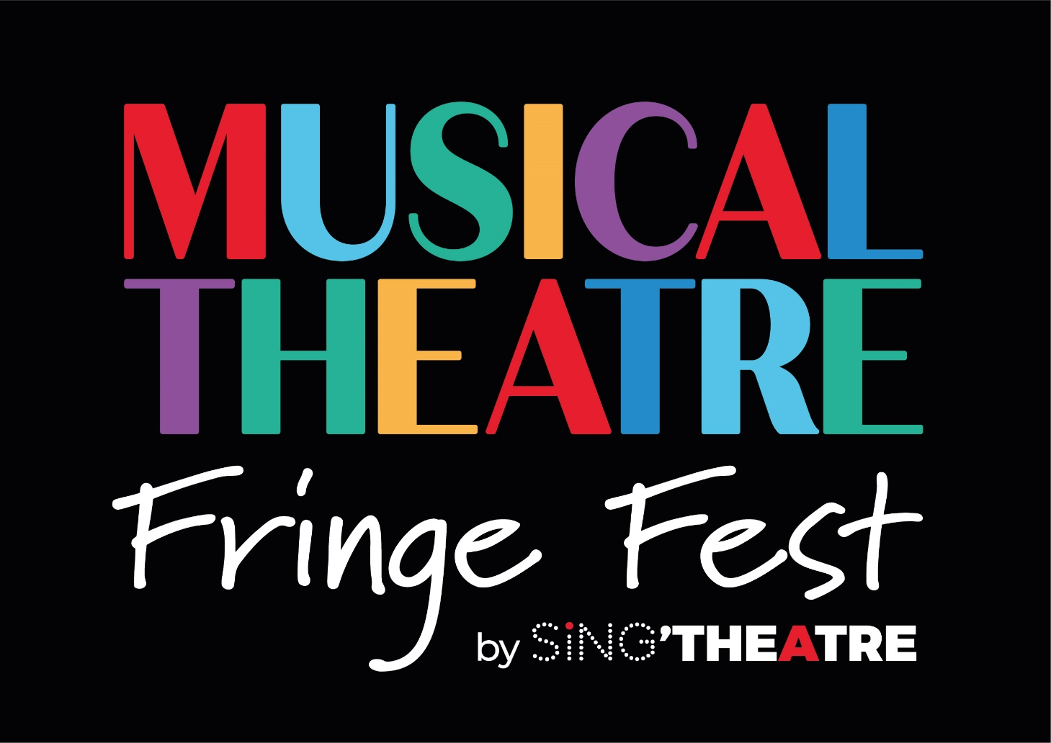

APPLICATION FORM

22nd July to 7th August 2022

About the Festival

Musical Theatre Fringe Festival (MTFF) is Singapore's first Festival dedicated to promoting Musical Theatre. Giving an opportunity for local artists to create, devise and showcase new and existing works. To allow audiences to watch, learn and engage in high-quality performances, workshops, and events by both local and international artists. MTFF aims to raise the appreciation of the musical theatre genre and enrich the lives of the Singapore community through education and shared cultural experiences.

HOW TO APPLY

Deadline for application: 1st April 2022, 2359 Singapore time

- Complete this application form.

- Email the completed form to: MTFF@singtheatre.com

- Attach any supporting documents in the email

HONORARIUM

Honorarium | Description
For Ticketed Shows | Artist/collective/groups will receive 60% of total ticket sales  Festival will receive 40% of total tickets sales
For Free show/event | A token fee will be negotiated with the individual artist/collective/ facilitator
For Paid workshops | A fee will be negotiated with the individual facilitator depending on the type of workshop
For Overseas Artist | A fee will be negotiated with the individual artist/collective/ facilitator that may include accommodation & flights cost.

RESPONSIBILITIES
Category | Description | Responsible Party
PRODUCTION
Venue - Theatre/ Studio | Mainstage Black Box Studio for the bump in & performance space for Shows  Studio space for workshops & other events | Festival
Production Cost | Any set/props/ artwork/ costumes/ additional equipment/ multimedia cost | Artist
Cast & Creatives Cost | Fee for all designers, cast & stage management crew | Artist
Crew | 1 x Front of House officer & 1 x Venue Technician will be provided  (Any additional FOH or Crew cost must be borne by Artist) | Festival
RIGHTS
Show Rights/ Royalties (For Complete/existing work) | Any staging, licensing and other royalties that need to be paid for your performance. | Artist
IMDA Application | Submission of IMDA Application & Fees | Festival
Compass Application  (For Live) | Compass Application & Fees for Live shows/events | Festival
Compass Application  (For Digital) | Compass Application & Fees for Digital shows/events | Artist
MARKETING & PUBLICITY
Individual Show/ event | Design and creation of materials, e.g., publicity posters and information about work. (To be approved by Festival team) | Artist
For the Festival as a whole | All creation & implementation of marketing and publicity campaign, including promotional and marketing collaterals (i.e. posters, Festival Programme booklet, website, etc.) | Festival
TICKETING
Platform | All ticketing costs & administration work for both free & paid events | Festival
OTHERS
Archival Photography/ Videography of events/shows | Photography & Videography of selected events  Artist may engage their on photographers & videographers to cover their individual event for Archival | Festival/Artist
Programming & Scheduling | All programming & scheduling work | Festival

Please assist to sign below to indicate all responsibilities in the above table are understood

ITEM | PLEASE FILL IN
Your name and role in this work
Signature

SUPPORTING MATERIALS NEEDED

- PROPOSAL FOR SHOW

Please fill up the following table

Show/ Event Title
Format
(Live/Online)
Original or Existing Work

Has the show been done below? If yes, where & when?
Description/ Synopsis
(Please specify language)
Any link for video/photo references of the material
Cast & Creatives involved
Duration
Expected Audience
(max 30 pax)
Free/ Paid Event
(Please state preferred pricing)
Reason for putting up the show/ event
Do you need extra cast/crew members?

Would you like to take part in our Open call Audition?

- VIDEO RECORDING – ONLY FOR VIRTUAL SHOWS

Please provide the link to watch your video online, e.g., Vimeo or Youtube.

For new work: Please submit a recording of your rehearsal or video proposal. You may also write to us at mtff@singtheatre.com to share your video proposal.

For Ready work: Please submit a full recording of the show.

Link to watch the video online
(Include password if any)

- SCRIPT (To be submitted with application form via email)

For New work: Please email us the draft or a draft structure of the show
For Existing work: Please email us the completed script

ARTIST DETAILS

ITEM | PLEASE FILL IN
Name of Artist/ Company
Company Status (if applicable)
Mailing address
Website
Contact person/ Role
Contact phone
Email
Link to CVs/Bio of key personals
(You may attach this in your email)
Can we add you to our mailing list?

SIGN OFF AT END OF FORM

ITEM | PLEASE FILL IN
How did you hear about the Musical Theatre Fringe Festival?
Your name and role in this work
Signature
Date of submission
(dd/mm/yy)

